**Module No. 3**

**Oops with java**

**Assignment No.3**

**Q1 Write a program to print table of any entered number using loop.**

import java.util.*;

class Test

{

public static void main(String args[])

{

Scanner sc=new Scanner(System.in);

System.out.println("Enter any number");

int a=sc.nextInt();

for(int i=1;i<=10;i++)

{

System.out.println(a+" * "+i+" = "+(a*i));

}

}

}

**//Output**

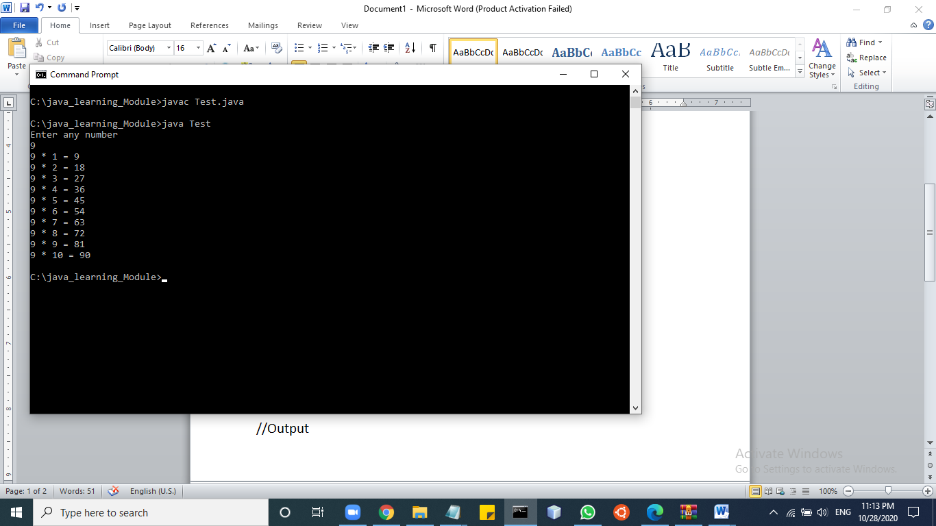

**Q2. Write a program to reverse a given number.**

import java.util.*;

class Test

{

public static void main(String[] args) {

int rev=0;

Scanner sc=new Scanner(System.in);

System.out.println("Enter any number: ");

int num=sc.nextInt();

while(num != 0) {

int digit = num % 10;

rev = rev * 10 + digit;

num /= 10;

}

System.out.println("Reverse number: " + rev);

}

}

**//Output**

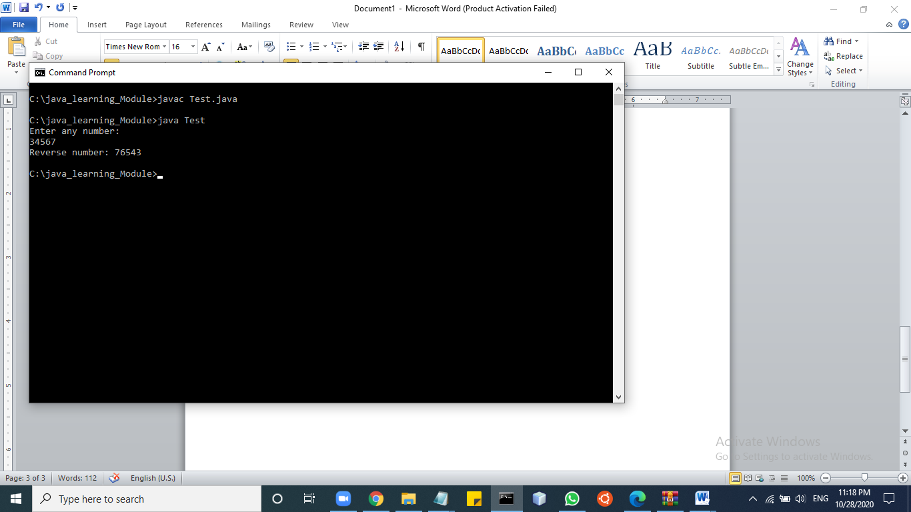

**Q3. Program to check whether number is prime or not**

import java.util.*;

class Test

{

public static void main(String[] args) {

int i,m=0,flag=0;

Scanner sc=new Scanner(System.in);

System.out.println("Enter any number: ");

int n=sc.nextInt();

m=n/2;

if(n==0||n==1){

System.out.println(n+" is not prime number");

}

else

{

for(i=2;i<=m;i++)

{

if(n%i==0){

System.out.println(n+" is not prime number");

flag=1;

break;

}

}

if(flag==0)

{

System.out.println(n+" is prime number");

}

}

}

}

**//Output**

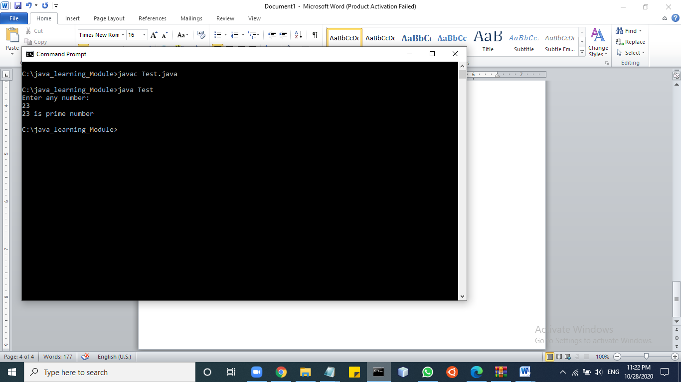

**Q4. Calculate series : 12+22+32+42+.........+n2**

import java.util.*;

class Test

{

public static void main( String[] args )

{

int i,sum=0;

Scanner sc=new Scanner(System.in);

System.out.println("enter last digit: ");

int n=sc.nextInt();

for(i=12;i<=n;i=i+10)

{

sum = sum + i;

}

System.out.println("Sum is : " +sum);

}

}

**//Output**

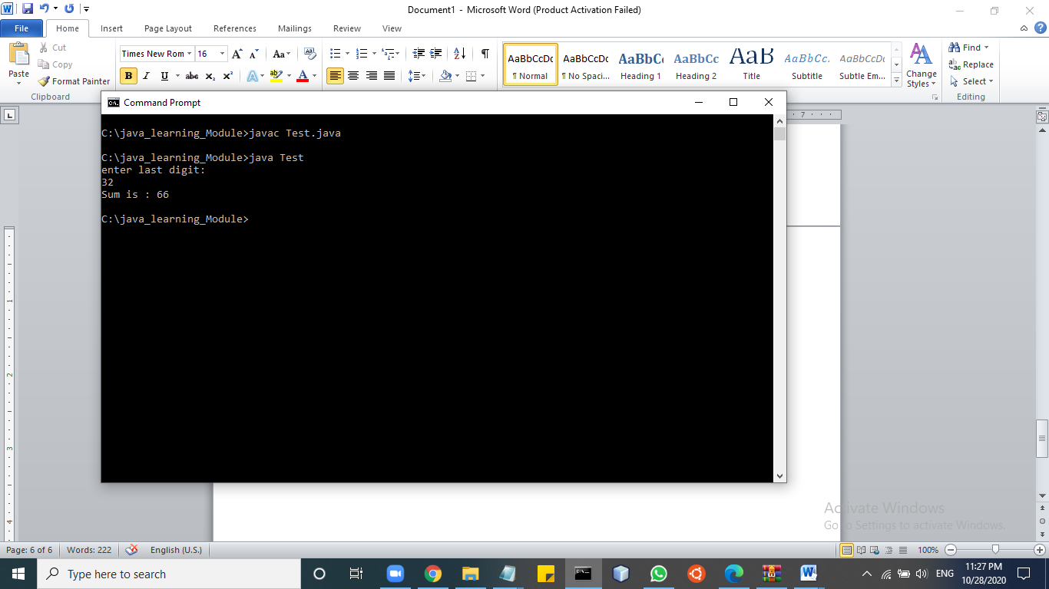

**Q5.Print all prime numbers between two given numbers. [ break continue ]**

import java.util.*;

class Test

{

public static void main( String[] args )

{

Scanner sc = new Scanner(System.in);

int a, b, i, j, flag;

System.out.printf("Enter first number: ");

a = sc.nextInt();

System.out.printf("Enter second number: ");

b = sc.nextInt();

for (i = a; i <= b; i++) {

if (i == 1 || i == 0)

continue;

flag = 1;

for (j = 2; j <= i / 2; ++j) {

if (i % j == 0) {

flag = 0;

break;

}

}

if (flag == 1)

System.out.println(i);

}

}

}

**//Output**

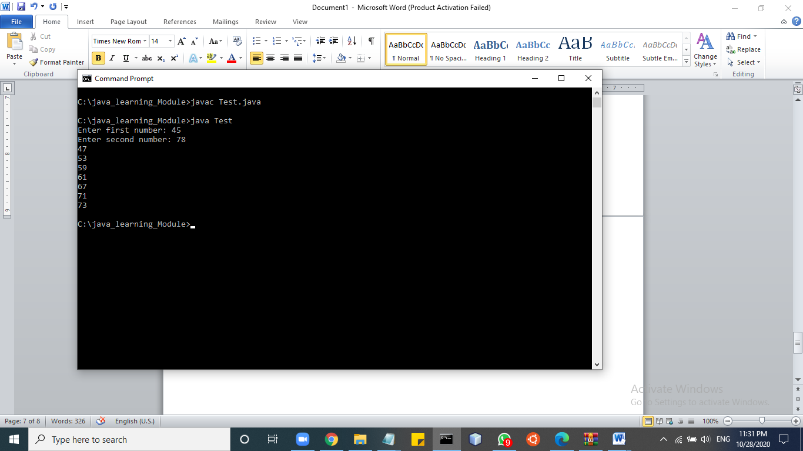

**Q6. Program to show sum and average of 10 element array. Accept array elements from user.**

import java.util.Scanner;

class Test

{

public static void main(String[] args)

{

int sum = 0;

float average;

Scanner s = new Scanner(System.in);

System.out.println("Enter all the elements:");

int[] a = new int[10];

for(int i = 0; i < 10 ; i++)

{

a[i] = s.nextInt();

sum = sum + a[i];

}

System.out.println("Sum:"+sum);

average = (float)sum / 10;

System.out.println("Average:"+average);

}

}

**//Output**

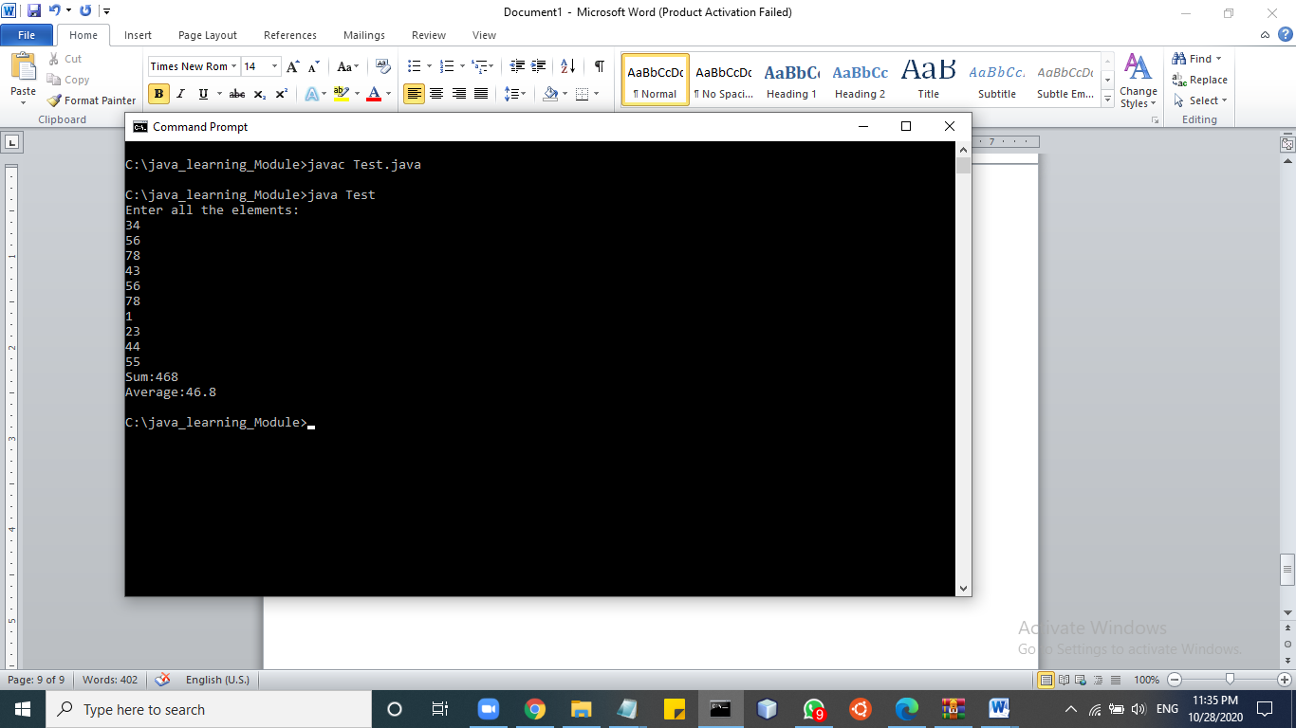

**Q7.Sort a ten element array in descending order.**

import java.util.*;

class Test

{

public static void main(String[] args) {

int [] arr = new int [] {5, 2, 8, 7, 1,33,12,6,4,87,};

int temp = 0;

System.out.println("Elements of original array: ");

for (int i = 0; i < arr.length; i++) {

System.out.print(arr[i] + " ");

}

for (int i = 0; i < arr.length; i++) {

for (int j = i+1; j < arr.length; j++) {

if(arr[i] < arr[j]) {

temp = arr[i];

arr[i] = arr[j];

arr[j] = temp;

}

}

}

System.out.println();

System.out.println("Elements of array sorted in descending order: ");

for (int i = 0; i < arr.length; i++) {

System.out.print(arr[i] + " ");

}

}

}

**//Output**

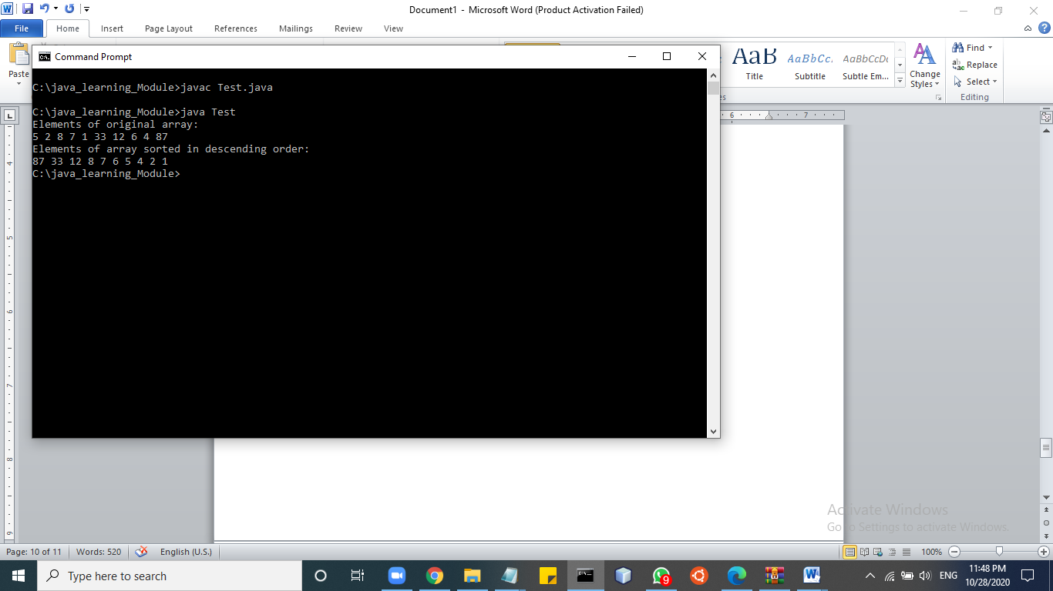

**Q8. Write a program to reverse the array elements.**

import java.util.*;

class Test

{

public static void main(String[] args)

{

int n, res,i,j=0;

Scanner s = new Scanner(System.in);

System.out.print("Enter number of elements in the array:");

n = s.nextInt();

int array[] = new int[n];

int rev[] = new int[n];

System.out.println("Enter "+n+" elements ");

for( i=0; i < n; i++)

{

array[i] = s.nextInt();

}

System.out.println("Reverse of an array is :");

for( i=n;i>0 ; i--,j++)

{

rev[j] = array[i-1];

System.out.println(rev[j]);

}

}

}

**//Output**

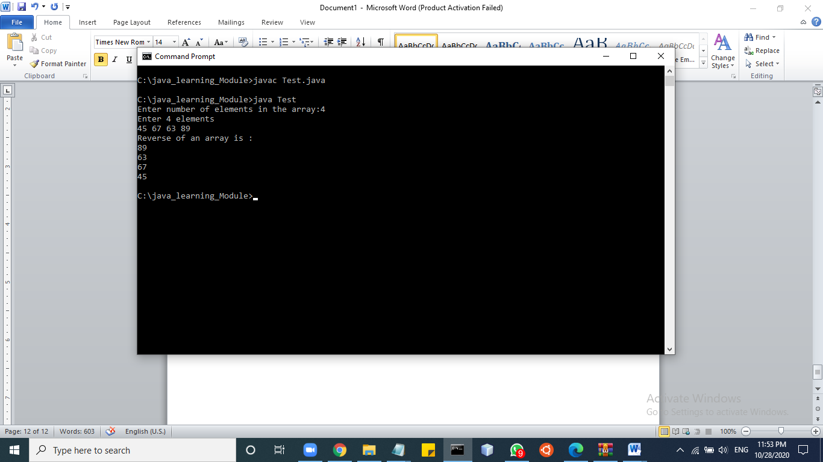

**Q9. Write a program to search an element in the array.**

import java.util.Scanner;

class Test

{

public static void main(String args[])

{

int c, n, search, array[];

Scanner in = new Scanner(System.in);

System.out.println("Enter number of elements");

n = in.nextInt();

array = new int[n];

System.out.println("enter array elements: ");

for (c = 0; c < n; c++)

array[c] = in.nextInt();

System.out.println("Enter elements to find");

search = in.nextInt();

for (c = 0; c < n; c++)

{

if (array[c] == search)

{

System.out.println(search + " element is present at location " + (c + 1));

break;

}

}

if (c == n)

System.out.println(search + " isn't present in array.");

}

}

**//Output**

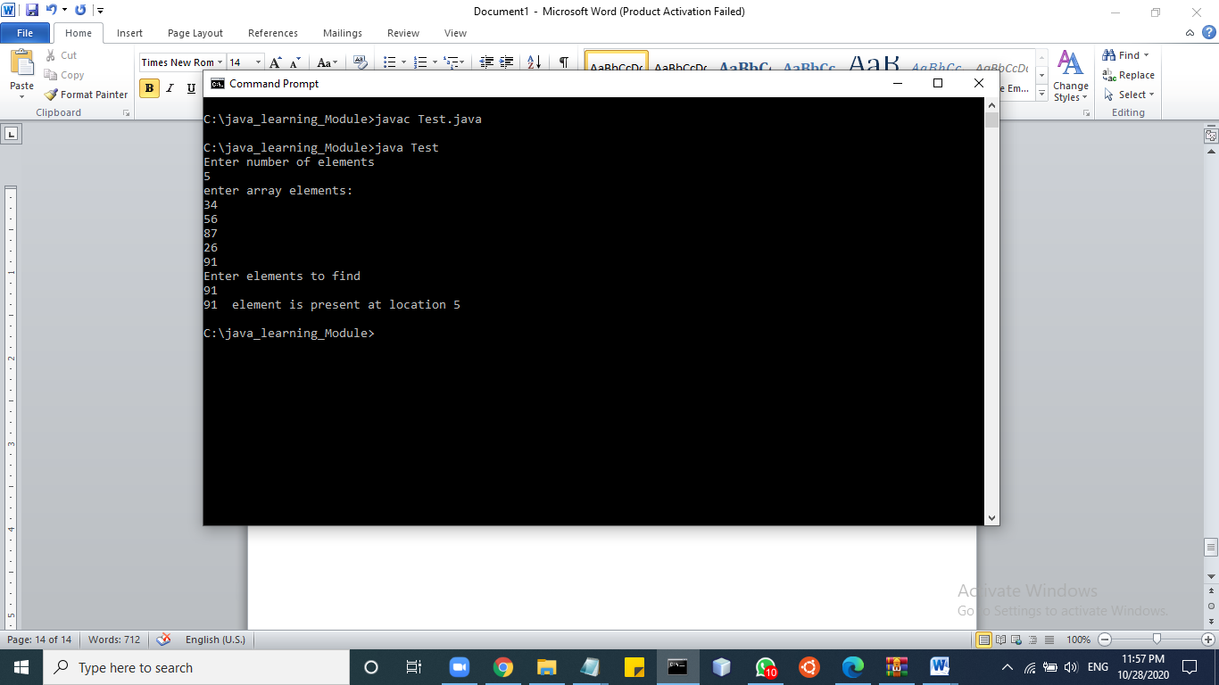

**Q 10.Write the program to find the sum of even elements and sum of odd elements present in the array of integer type.**

import java.util.Scanner;

public class Test

{

public static void main(String[] args)

{

int n, sumE = 0, sumO = 0;

Scanner s = new Scanner(System.in);

System.out.print("Enter the number of elements in array:");

n = s.nextInt();

int[] a = new int[n];

System.out.println("Enter the elements of the array:");

for(int i = 0; i < n; i++)

{

a[i] = s.nextInt();

}

for(int i = 0; i < n; i++)

{

if(a[i] % 2 == 0)

{

sumE = sumE + a[i];

}

else

{

sumO = sumO + a[i];

}

}

System.out.println("Sum of Even Numbers:"+sumE);

System.out.println("Sum of Odd Numbers:"+sumO);

}

}

**//Output**

